Catalog Degree Requirements Worksheet for Graduate Programs
Name of Program _________________________ School of ___________________________
==============================================================================
Attach this document to the New Graduate Program Request form when submitting for the curricular review process. This worksheet is a guide to think about how the program is structured. It is acceptable to manipulate these tables to accommodate your requirements. Accuracy is important here as this information will be used to program the official degree audit. Feel free to add notes between the tables to help explain the nuances of the program requirements.

Department | Certificate | Master’s | CIP Code | Minimum Semester Credit Hours required

Program Overview (Description of the program for the catalog)

Program Admission Requirements (beyond the Graduate School’s minimum requirements)
Major admission requirements are any requirements beyond the Graduate School’s minimum requirements to be met to be admitted to the major. The Graduate School Admission Requirements can be found here: https://www.untdallas.edu/gradschool/requirements.php. Programs may specify admission criteria that are more stringent than the Graduate School’s minimum requirements. Graduate School minimum requirements will be assumed if no additional requirements are listed.

Program Progression/Benchmark Requirements (beyond the Graduate School’s requirements)
Progression requirements are included when programs are sequenced and structured in a manner that requires completion of certain courses/experiences/benchmarks to advance in the program. The Graduate School policies on progression/continuance can be found in the Graduate Catalog mostly under “The Graduate School” and “Academic Regulations” sections.

Other Program Requirements/Information – any requirements that the university is expected to enforce specific to your academic program must be outlined in the catalog. An example would be requiring a specific letter grade in a particular course(s) or comprehensive exams.

Program Background/Leveling Courses (if applicable) - Provide the list of undergraduate or graduate
(preferred) program leveling courses students may be required to complete. List all
potential courses to be required (i.e., some students may need to take only one; others
may be required to take all courses).
Example:
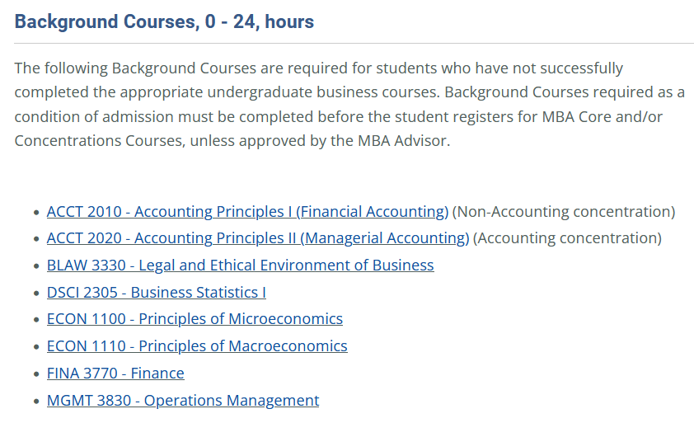
Required Courses
Prefix & Course Number | Course Title | Hours

Required Core Courses - Required courses provide a foundation for in-depth
understanding of the discipline. Required courses are taken by all students in the major.
Required courses typically draw primarily from one academic department; however,
interdisciplinary programs may include courses from more than one department.
Example:
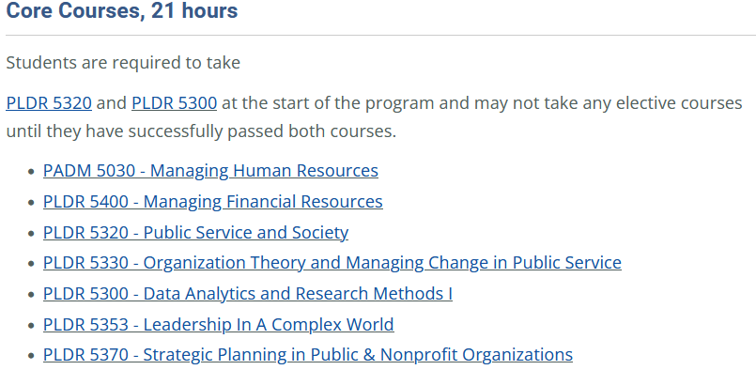
Required Courses: -------------------------; hours required: ----------------
Prefix & Course Number | Course Title | Hours
Prescribed Electives (if applicable) - Prescribed electives provide guidance to students for
exploring courses within the discipline or field of study. Prescribed electives complement
required core courses and are numerous enough to provide breadth and depth of study.
Prescribed electives: -------------------------; hours required: ----------------
Prefix & Course Number | Course Title | Hours

Concentration (if applicable) - A concentration is a designated and coherent set of courses designed to develop an area of emphasis within the major.
Concentration: --------------------; hours required: ----------------
Prefix & Course Number | Course Title | Hours

Thesis Option (if applicable) - describe the requirements for completing a thesis and list the thesis course numbers.
Thesis: --------------------; hours required: ----------------
Prefix & Course Number | Course Title | Hours

Non-Thesis Option (if applicable) - describe the requirements for students on the non-thesis plan. These can be course requirements, comprehensive exam requirements, etc.
Thesis: --------------------; hours required: ----------------
Prefix & Course Number | Course Title | Hours

